***Electric Charges And Fields***

***Topic:-***

***1-Electric field lines. 2-Electric flux. 3-Electric dipole. 4- Dipole in a uniform external field. 5-Continous charge distribution.***

**ELECTRIC FIELD LINES**

**Electric lines of force**

Michael Faraday (1791 -1867) introduced the concept of lines of force to visualize the nature of electric and magnetic fields. A small positive charge placed in an electric field experiences a force in a definite direction and if it is free to move, it will start moving in that direction. The path along which this charge would move will be a line of force.

*An* ***electric line of force*** *may be defined as the curve along which a small positive charge would tend to move when free to do so in an electric field and the tangent to which. At any point gives the direction of the electric field at that point.*

In the below figure, the curve *PQR* is an electric line of force. The tangent drawn to this curve at the point *P* gives the direction of the field at the point *P*. Similarly, the tangent at the point *Q* gives the direction of the field, at the point *Q* and so on.

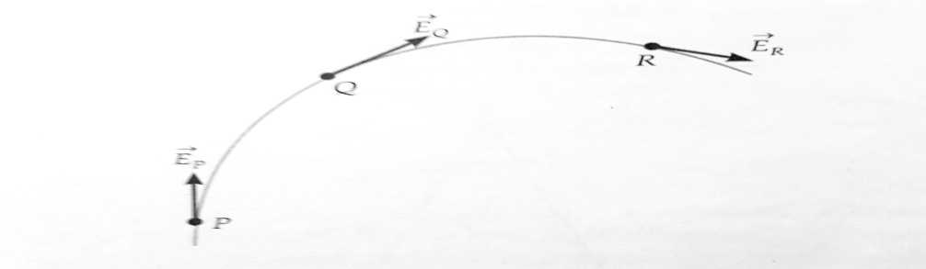

An electric line of force.

The lines of force do not really exist, they are imaginary curves. Yet the concept of lines of force is very useful. Michael Faraday gave simple explanations for many of his discoveries (in electricity and magnetism) in terms of such lines of force.

**Properties of Electric Lines of Force**

I. The lines of force are continuous smooth curves without any breaks

2. The lines of force start at positive charges and end at negative charges. They cannot form closed loops. If there is a single charge, then the lines of force will start or end at infinity.

3. The tangent to a line of force at any point gives the direction of the electric field at that point.

4. No two lines of force can cross each other.

***Reason****, if they intersect, then there will be two tangents at the point of intersection (In above figure) and hence two directions of the electric field at the same point, which is not possible.*

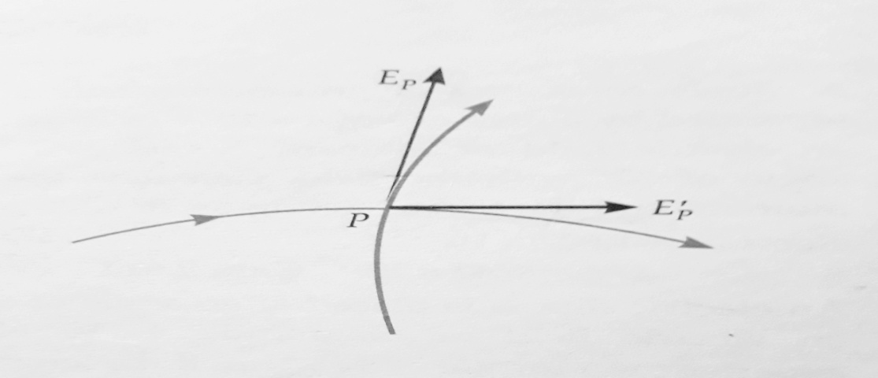

5. The lines of force are always normal to the surface of a conductor on which the charges are in equilibrium.

***Reason****, if the lines of force are not normal to the conductor, the component of the field parallel to the surface would cause the electrons to move and would set up a current on the surface. But no current flows in the equilibrium condition.*

6. The lines of force have a tendency to contract lengthwise. This explains attraction between two unlike charges.

7. The lines of force have a tendency to expand laterally so as to exert a lateral pressure on neighbouring lines of force. This explains repulsion between two similar charges.

8. The relative closeness of the lines of force gives a measure of the strength of the electric field in any region. The lines of force are

(1) Close together in a strong field.

(ii) Far apart in a weak field.

(iii) Parallel and equally spaced in a uniform field.

9. The lines of force do not pass through a conductor because the electric field inside a charged conductor is zero.

**ELECTRIC FIELDS LINES FOR DIFFERENT CHARGED CONDUCTORS**

**Electric field lines for different charge systems:**

(1) **Field lines of a positive point charge**. Figure shows the lines of force of an isolated positive point charge. They are directed radially outwards because a small positive charge would be accelerated in the outward direction. They extend to infinity. The field is ***spherically, symmetric*** i.e., it looks same in all directions, as seen from the point charge.

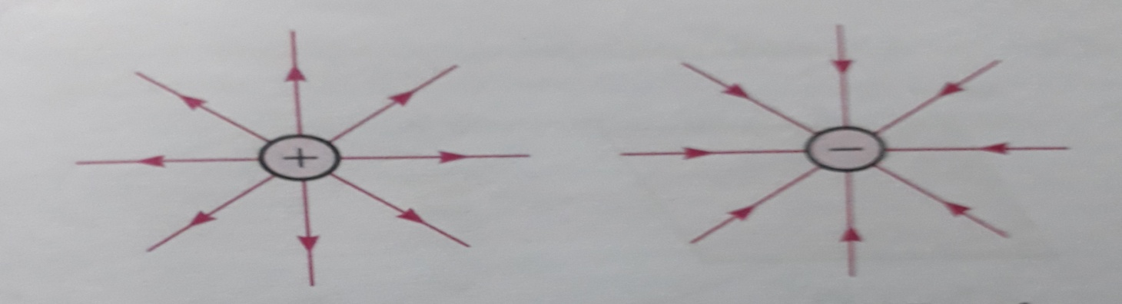

(Field lines of a positive point charge) (Field lines of a negative point charge)

(ii) ***Field lines of a negative point charge***. Like that of a positive point charge, the electric field of a negative point charge is also spherically symmetric but the lines of force point radially inwards as shown in above figure. They start from infinity.

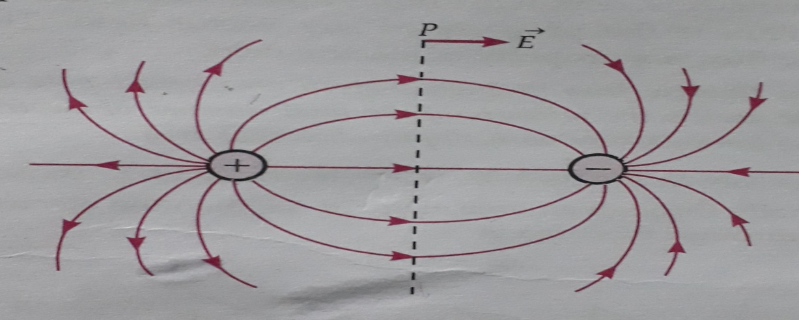

Field lines of an electric dipole

(iii) ***Field lines of two equal and opposite point charges***. In above figure, shows the electric lines of force of an electric dipole i.e., a system of two equal and opposite point charges (± q) separated by a small distance. They start from the positive charge and end on the negative charge. The lines of force seem to contract lengthwise as if the two charges are being pulled together. This explains attraction between two unlike charges. The field is ***cylindrically symmetric*** about the dipole axis i.e., the field pattern is same in all planes passing through the dipole axis. Clearly, the electric field at all points on the equatorial line is parallel to the axis of the dipole.

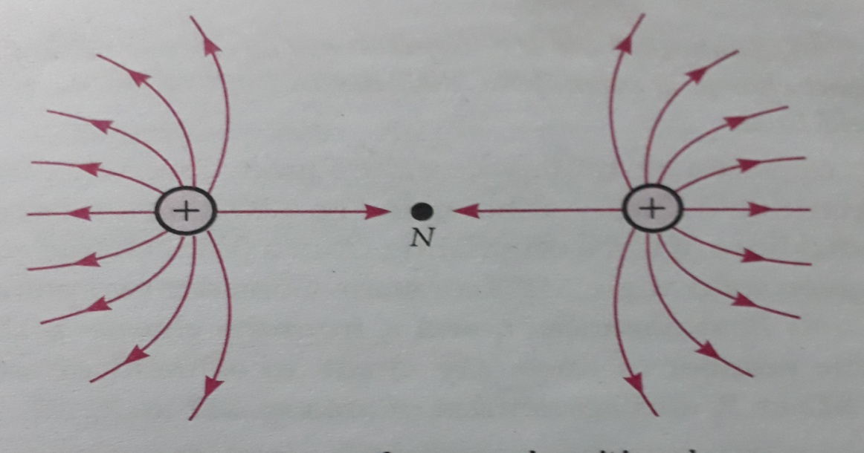

Field lines of two equal positive charges.

(iv) ***Field lines of two equal and positive point charges***. In above figure shows the lines of force of two equal and positive point charges. They seem to exert a lateral pressure as if the two charges are being pushed away from each other. This explains repulsion between two like charges. The electric field is zero at the middle point *N* of the join of two charges. This point is called neutral point from which no line of force passes. This field also has cylindrical symmetry.

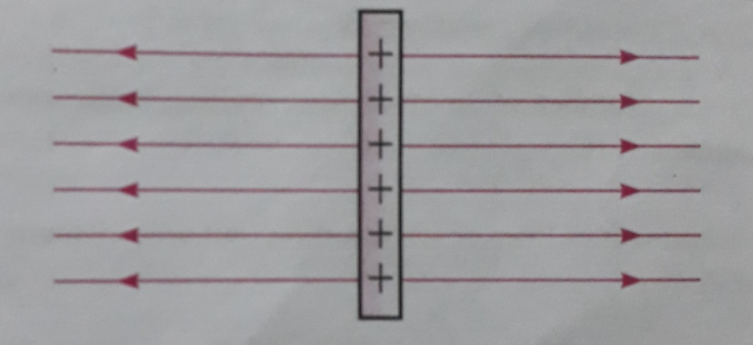

Field lines of two equal positive charges.

(v) ***Field lines of a positively charged plane conductor***. In above figure, shows the pattern of lines of force of positively charged plane conductor. A small positive charge would tend to move normally away from the plane conductor. Thus the lines of force are parallel and normal to the surface of the conductor. They are equispaced, indicating that electric field is uniform at all points near the plane conductor.

***Relation between electric field strength and density of lines of force***

Electric field strength is proportional to the density of lines of force i.e., electric field strength at a point is proportional to the number of lines of force cutting a unit area element placed normal to the field at that point. As illustrated in Figure, the electric field at *P* is stronger than at *Q*.

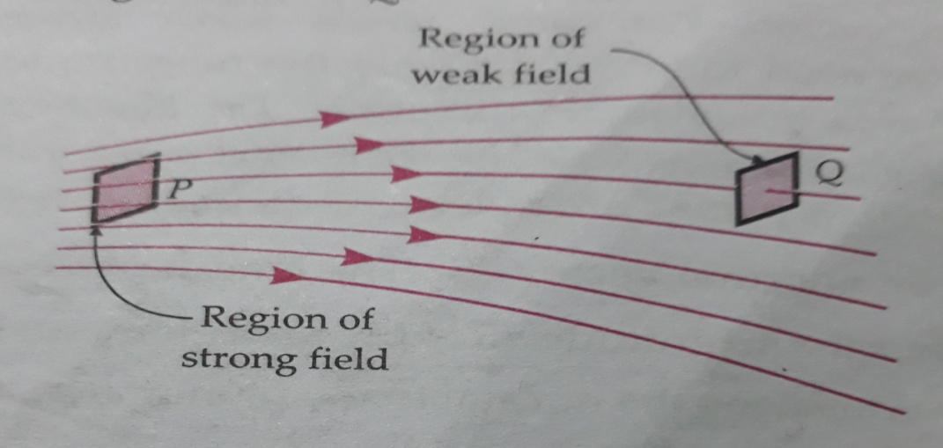

Density of lines of force is proportional to the electric field strength.

**Consistency of the inverse square law with the electric field lines**

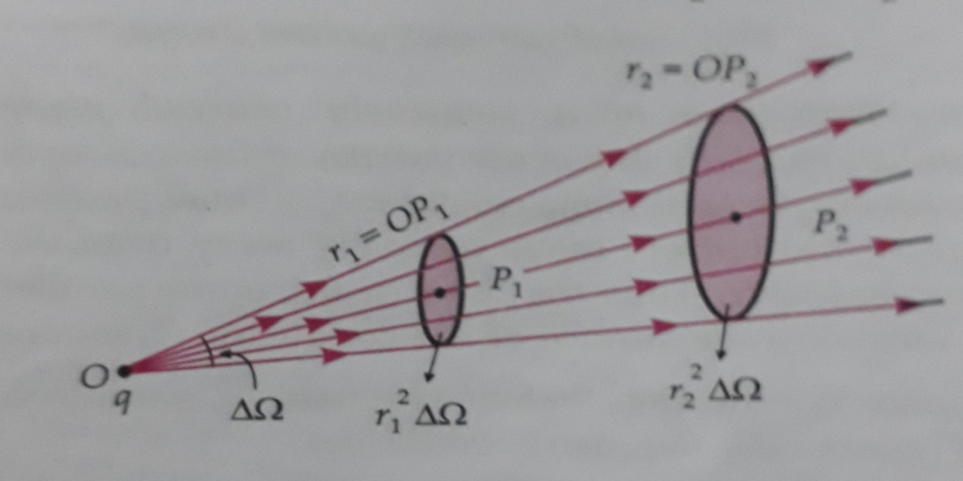

As shown in figure, the number of radial lines of force originating from a point charge *q* in a given solid angle ∆ is constant. Consider two points’ *p1* and *p2* at distances r1 and r2 from the charge *q.* The same number of lines (say n) cut an element of area r12 ∆ at p1 and an element of area r22 ∆ at *p2*.

Number of lines of force cutting unit area element at

P1 =

Number of lines of force cutting unit area element at

P2 =

As electric field strength α Density of lines of force

= =

E α

**AREA VECTOR**

We come across many situations where we need to know not only the magnitude of a surface area but also its direction. *The direction of a planar area vector is specified by the normal to the plane.* In given figure, a planer area element *dS* has been represented by normal vector *dS*. The length of vector *dS* represents the magnitude *dS* of the area element. If *ň* is a unit vector along the normal to the planar area, then

= *dS*

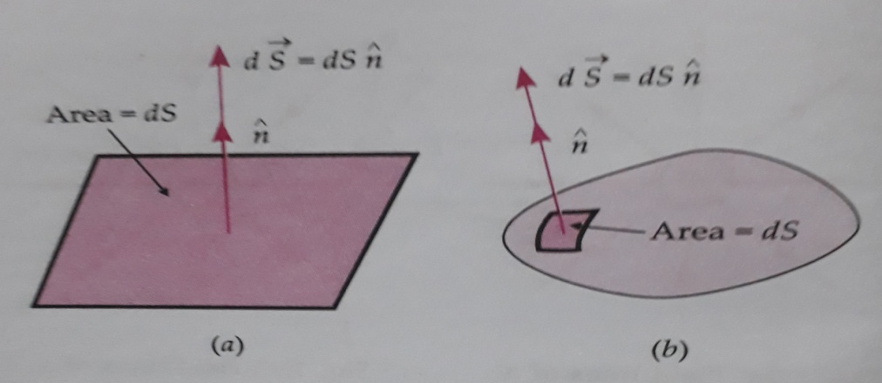

(a) A planar area element. (b) An area element of a curved surface.

In case of a curved surface, we can imagine it to be divided into a large number of very small area elements. Each small area element of the curved surface can be treated as a planar area. By convention, the direction of the vector associated with every area element of a closed surface is along the *outward drawn normal*. As shown in Figure (b), the area element vector *dS* at any point on the closed surface is equal to *dS* n , where *dS* is the magnitude of the area element and ň is a unit of vector in the direction of outward normal.

**ELECTRIC FLUX**

The term flux implies some kind of flow. Flux is the property of any vector field. The electric flux is a property of electric field.

*The* ***electric flux*** *through a given area held inside an electric field is the measure of the total number of electric lines of force passing normally through that area.*

As shown in figure, if an electric field passes normally through an area element *∆S*, then the electric flux through this area is

*∆ = E ∆S*

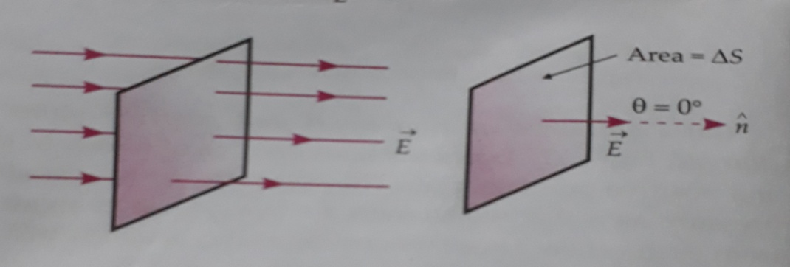

*Electric* flux through normal area

As shown in above figure, if the normal drawn to the area element *∆S* makes an angle with the uniform electric field , then the component of electric field normal to *∆S* will be *Ecos ,* so that the electric flux is

∆= Normal component of *E* Surface area

∆ = *Ecos*  *∆S*

Or ∆=

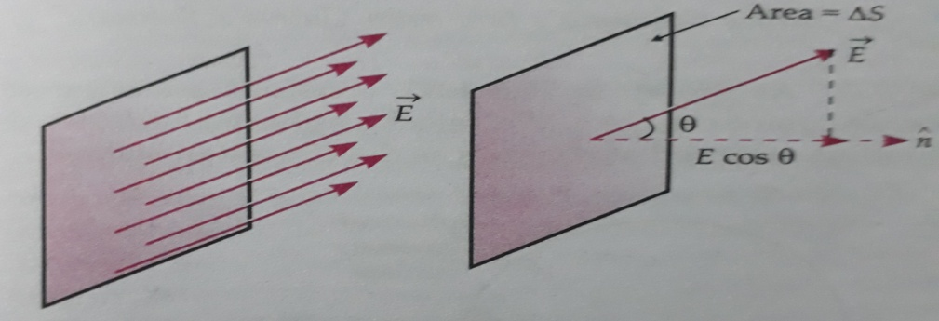

Flux through an inclined area

In case of the electric field is non- uniform, we consider a closed surface *S* laying inside the field, as shown in given figure below. We can divide the surface S into small area element . Let the corresponding electric field at these element be,.

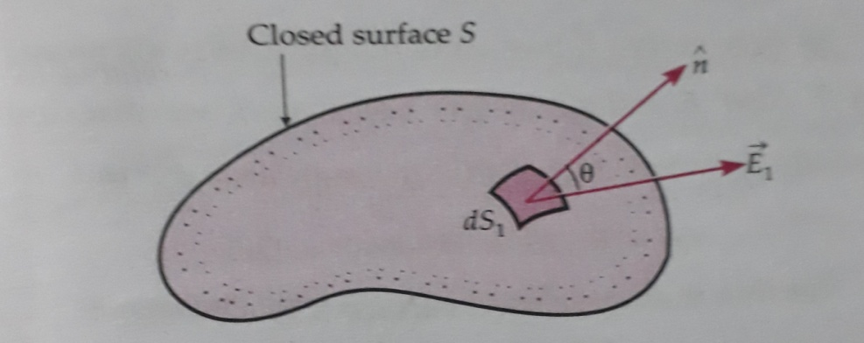

Electric flux through a closed surface(*S*).

Then the electric flux through the surface S will be

=

=

When the number of area elements becomes infinitely large (N→ ) and ∆S→0 the above sum approaches a surface integral taken over the closed surface. Thus

=

=

Thus the electric flux through any surface, open or closed, is equal to the surface integral of the electric field taken over the surface taken over the surface.

Electric flux is a scalar quantity.

Unit of = Unit of E Unit of S

SI unit of electric flux = NC-1 m -2 = **Nm-2C-1**

Equivalently, SI unit of electric flux =Vm-1.m2 = **V m.**

**ELECTRIC DIPOLE**

*A pair of equal and opposite charges separated by a small distance is called an electric dipole.*

**Dipole moment**

It measures the strength of an electric dipole. *The dipole moment of an electric dipole is a vector whose magnitude is either charge times the separation between the two opposite charges and the direction is along the dipole axis from the negative to the positive charge.*

As shown in Figure, consider an electric dipole consisting of charges *+ q* and *— q* and separated by distance *2a*. The line joining the charges is called dipole axis.

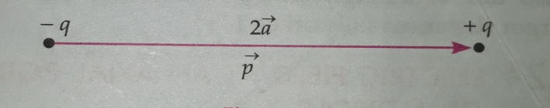

Dipole moment = either charge x a vector drawn from negative to positive charge

Or = *q*

Thus the dipole moment is a *vector* quantity. Its direction is along the dipole axis from *— q* to *+ q* and its magnitude is

*P = q x 2a*

The SI unit of dipole moment is *coulomb meter* (Cm). When both the charge *q* and separation *2a* are finite, the dipole has a finite size (equal to *2a*), a location (midpoint between *+ q* and *— q*), a direction and strength.

**Examples of electric dipoles**

Dipoles are common in nature. In molecules like H20, HCI, C2H5 OH, CH3COOH, etc., the centre of positive charges does not fall exactly over the centre of negative charges. Such molecules are electric dipoles. They have a permanent dipole moment.

**Ideal or point dipole**

We can think of a dipole in which size 2a→0 and charge q→ in such a way that the dipole moment p=q 2a has a finite value. Such a *dipole of negligible small size is called an ideal or point dipole.*  Dipole associated with individual atoms or molecules may be treated as ideal dipole. An ideal dipole is specified only by its location and a dipole moment, as it has no finite size.

**DIPOLE FIELD**

**Dipole field**

*The electric field produced by an electric dipole is called a dipole field.* This can be determined by using (a) the formula for the field of a point charge and (b) the principle of superposition.

**Variation of dipole field with distance**

The total charge of an electric dipole is zero. But the electric field of an electric dipole is not zero. This is because the charges *+ q* and *—q* are separated by some distance, so the electric fields due to them when added do not exactly cancel out. However, at distances much larger than the dipole size (r>>2a), the fields of *+q* and *-q* nearly cancel out. Hence we expect a dipole field to fall off, at larger distance, faster than , typical of the field due to a single charge. In fact a dipole field at larger distances falls off as.

**ELECTRIC FIELD AT AN AXIAL POINT OF A DIPOLE**

**Electric field at an axial point of an electric dipole**

As shown in Figure, consider an electric dipole consisting of charges *+ q* and *— q*, separated by distance *2a* and placed in vacuum. Let *P* be a point on the axial line at distance *r* from the centre *0* of the dipole on the side of the charge *+ q*.

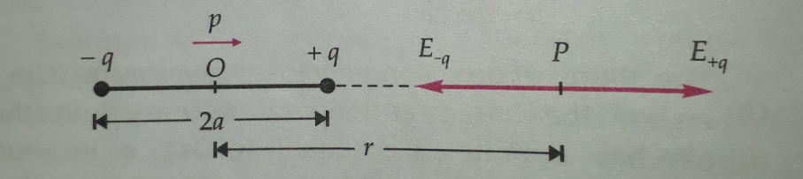

Electric field at an axial point of dipole.

Electric field due to charge - q at point P is

= (towards left)

Where is a unit vector along the dipole axis from —q to +q.

Electric field due to charge *+ q* at point *P* is

= (towards right)

Hence the resultant electric field at point *P* is

= +

= +

=

=

=

=

Here *p = q x 2a* = dipole moment

For r >> a, a2 can be neglected compared to r2.

= (toward right)

Clearly, electric field at any axial point of the dipole acts along the dipole axis from negative to positive charge i.e., in the direction of dipole moment .

**ELECTRIC FIELD AT AN EQUATORIAL POINT OF A DIPOLE**

**Electric field at an equatorial point of a dipole**

As given figure, consider an electric dipole consisting of charges *- q* and *+ q*, separated by distance *2a* and placed in vacuum. Let *P* be a point on the equatorial line of the dipole at distance *r* from it.

i.e., OP *= r*

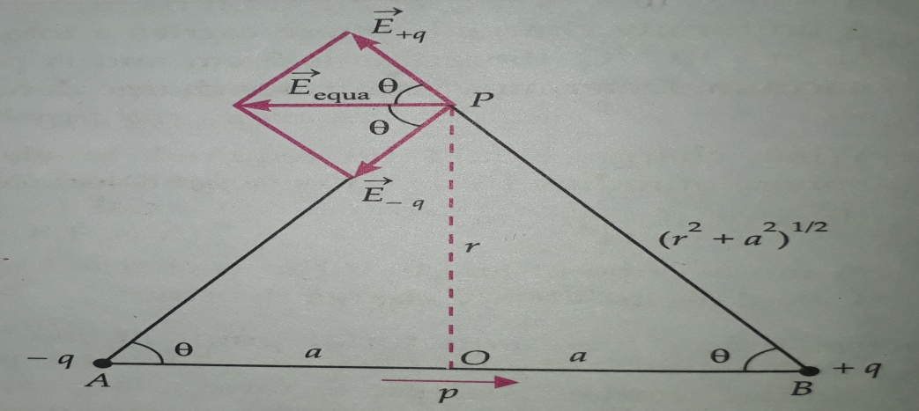

Electric field at an equatorial point of a dipole.

Electric field at point *P* due to *+q* charge is

= , directed along BP

Electric field at point *P* due to *— q* charge is

= , directed along PA

Thus the magnitudes of and are equal i.e.,

= =

Clearly, the components of and normal to the dipole axis will cancel out. The components parallel to the dipole axis add up. The total electric field is opposite to .

= -( + )

= - 2

= -2 .

=

Where *p= 2qa* is the electric dipole moment. If the point *p* is located far away from the dipole, r>>a, than

=

Clearly, the direction of electric field at any point on the equatorial line of the dipole will be ant parallel to the dipole moment .

**Comparison of electric fields of a short dipole at axial and equatorial points**

The magnitude of the electric field of a short dipole at an axial point at distance *r* from its centre is

=

Electric field at an equatorial point at the same distance r is

=

Clearly, = 2

Hence the *electric field of a short dipole at a distance r along its axis is twice the electric field at the same distance along the equatorial line.*

**TORQUE ON A DIPOLE IN A UNIFORM ELECTRIC FIELD**

**Torque on a dipole in a uniform electric field**

As shown in given figure, consider an electric dipole consisting of charges *+ q* and *- q* and of length *2a* Placed in a uniform electric field making an angle with it. It has a dipole moment of magnitude,

*p = q x 2a*

Force exerted on charge + q by field = q (along)

Force exerted on charge –q by field = -q (­opposite to )

= q -q = 0

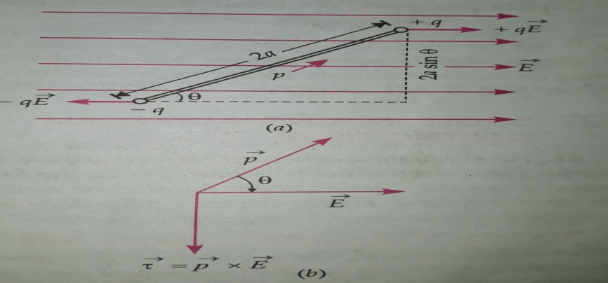

(a) Torque on a dipole in a uniform electric field.

(b) Direction of torque as given by right hand screw rule.

Hence the net translating force on a dipole in a uniform electric field is zero. But the two equal and opposite forces act at different points of the dipole. They form a couple which exerts a torque.

Torque = either force x Perpendicular distance between the two forces

= qE 2a sin = (q 2a) E sin

Or = pE sin (p=2qa)

As the direction of torque is perpendicular to both and, so we can write

The direction of vector is that in which a right handed screw would advance when rotated from

. As shown in above figure (b), the direction of vector is perpendicular to, and points into the plane of paper.

When the dipole is released, the torque tends to align the dipole with the electric field i.e., tends to reduce angle to 0. When the dipole gets aligned with electric field, the torque becomes zero.

Clearly, the torque on the dipole will be maximum when the dipole is held perpendicular to electric field. Thus

= pE sin 90° = pE.

**Dipole moment**. We know that the torque,

= pE sin

If E =1 unit, = 90°,

Then = p

Hence ***dipole moment*** *may be defined as the torque acting on an electric dipole, placed perpendicular to a uniform electric field of unit strength*.

**DIPOLE IN A NON-UNIFORM ELECTRIC FIELD**

**Dipole in a non-uniform electric field**

In a non-uniform electric field, the *+ q* and *— q* charges of a dipole experience different forces (not equal and opposite) at slightly different positions in the field and hence a net force acts on the dipole in a non-uniform field. Also, a net torque acts on the dipole which depends on the location of the dipole in the non-uniform field

Where is the position vector of the centre of the dipole.

**When the dipole is parallel or antiparallel to electric field**

In a non-uniform field, if s parallel to or antiparallel to the net torque on the dipole is zero (because the forces on charges ± q become -linear). However, there is a net force on the dipole. As shown in figure, when is parallel to a net force acts on the dipole in the direction of increasing. When is antiparallel to a net force acts in the direction of decreasing.

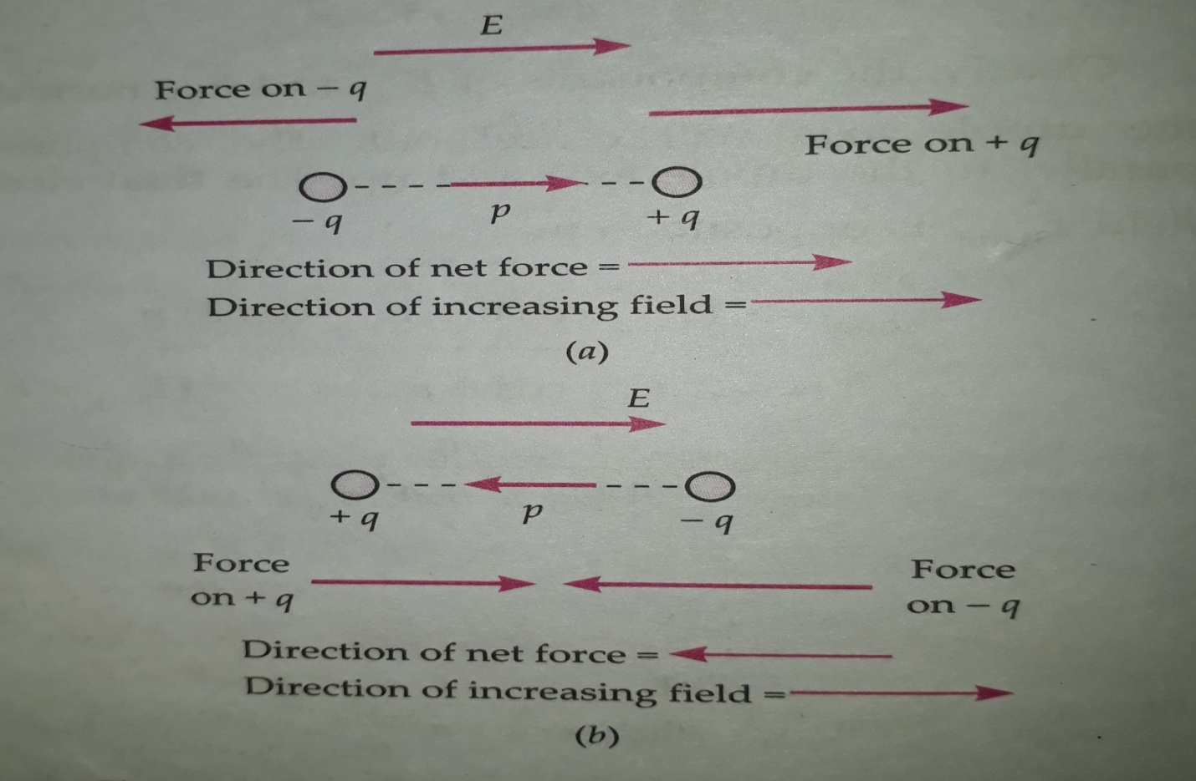

Forces on a dipole (a) when is parallel to and (b) when is antiparallel to.

**A comb run through dry hair attracts small pieces of paper**

As the comb runs through hair, it acquires charge due to friction. When the charged comb is brought closer to an uncharged piece of paper, it polarizes the piece of paper i.e., induces a net dipole moment in the direction of the field. But the electric field due to the comb on the piece of paper is not uniform. It exerts a force in the direction of increasing field i.e., the piece of paper gets attracted towards the comb.

**Physical significance of electric dipoles**

Electric dipoles have a common occurrence in nature. A molecule consisting of positive and negative ions is an electric dipole. Moreover, a complicated array of charges can be described and analyses in terms of electric dipoles. The concept of electric dipole is used (i) in the study of the effect of electric field on an insulator, and (ii) in the study of radiation of energy from an antenna.

**CONTINUOUS CHARGE DISTRIBUTION**

**Continuous charge distribution**

In practice, we deal with charges much greater in magnitude than the charge on an electron, so we can ignore the quantum nature of charges and imagine that the charge is spread in a region in a continuous manner. Such a charge distribution is known as a ***continuous charge distribution***.

**Calculation of the force on a charge due to a continuous charge distribution**

As shown in figure consider a point charge *q0*  lying near a region of continuous charge distribution. This continuous charge distribution can be imagined to consist of a large number of small charges *dq*. According to Coulomb's law, the force on point charge *qo* due to small charge *dq* is

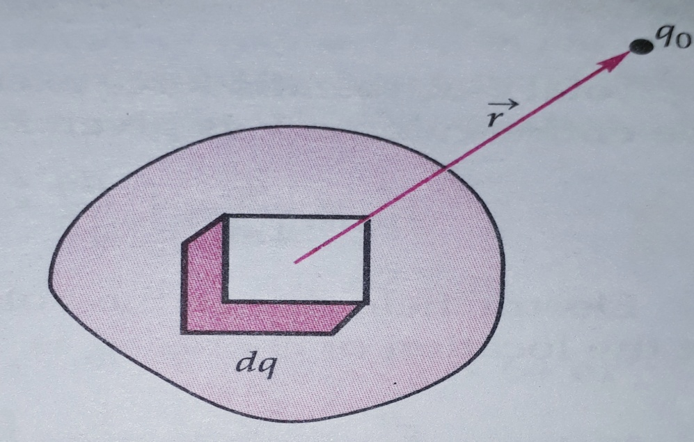

Force on a point charge *q0* due to a continuous charge distribution.

Where = , is a unit vector pointing from the small charge *dq* towards the point charge *qo*. By the principle of superposition, the total force on charge *qo* will be the vector sum of the forces exerted by all such small charges and is given by

Or =

**Different types of continuous charge distributions**.

There are *three* types of continuous charge distributions

(a) **Volume charge distribution**. *It is a charge distribution spread over a three dimensional volume or region V of space, as shown in Figure. We define the* ***volume charge density*** *at any point in this volume as the charge contained per unit volume at that point, i.e.,*

*=*

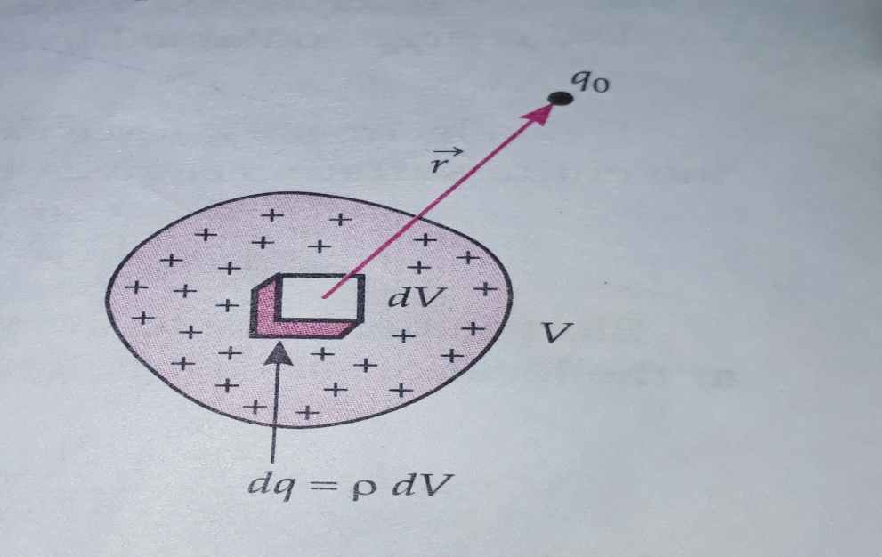

Volume charge distribution

The SI unit for volume charge distribution is coulomb per cubic meter (Cm-3). For example, if a charge *q* is distributed over the entire volume of a sphere of radius *R*, then its volume charge density is

C

The charge contained in volume *dV* is

*dq = p dV*

Total electrostatic force exerted on charge *q0* due to the entire volume *V* is given by

=

*= dV*

Electric field due to the volume charge distribution at the location of charge *q0* is

*= = dV*

(b) **Surface charge distribution**. *It is a charge distribution spread over a two-dimensional* *surface S in space*, as shown in Figure. We define the ***surface charge density*** *at any point on this surface as the charge per unit area at that point, i.e.,*

=

The SI unit for is Cm-2.

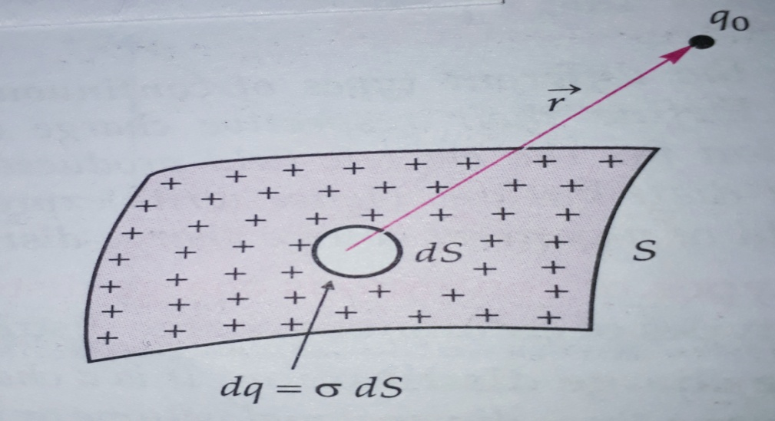

Surface charge distribution

*For example*, if a charge *q* is uniformly distributed over the surface of a spherical conductor of radius *R*, then its surface charge density is

= Cm-2

The charge contained in small area *dS* is

*dq = dS*

Total electrostatic force exerted on charge *q0* due to the entire surface *S* is given by

=

Electric field due to the surface charge distribution at the location of charge *q0*  is

= =

(c) **Line charge distribution**. It is a charge distribution along a one-dimensional curve or line *L* in space, as shown in Figure. We define the ***line charge density*** at any point on this line as the charge per unit length of the line at that point, i.e.,

=

The SI unit for is Cm-1.

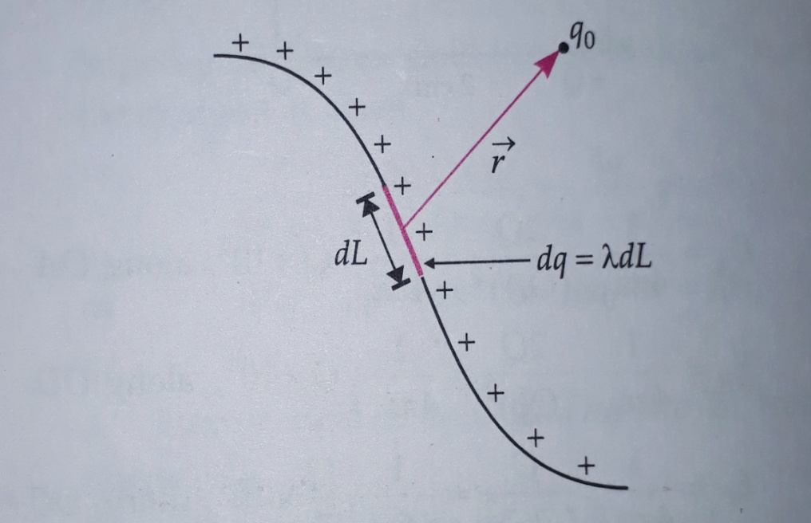

Line charge distribution.

*For example*, if a charge *q* is uniformly distributed over a ring of radius *R*, then its linear charge density is

λ = Cm-1

The charge contained in small length *dL* is

*dq = λ dL*

Total electrostatic force exerted on charge *q0* due to the entire length *L* is given by

*= dL*

Electric field due to the line charge distribution at the location of charge *q0* is

= =

The total electric field due to a continuous charge distribution is given by

= + +

=

**General charge distribution**. A general charge distribution consists of continuous as well as discrete charges. Hence total electric field due to a general charge distribution at the location of charge *q0* is given by

= +

=

In all the above cases, is a variable unit vector directed from each point of the volume, surface or line charge distribution towards the location of the point charge *q0*.